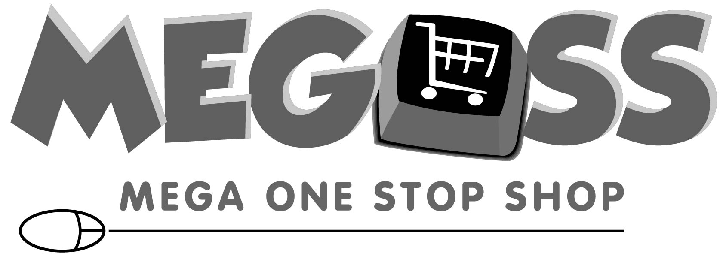 Customer Credit Form

Company Name (Doing Business As) Full Legal Business Name

Address (Cannot be a PO Box)

City State\Province Zip Code County/District

Fax Number Email Address

Billing Address (If different from above) City State\Province Zip Code

Owner Date Business Established
SECTION 1
No. of Employees:  1-10  11-50  50+

Please Check the following:  Desire to do business on a cash basis. Transaction by cash, company check, AmEx, Mastercard, Visa Card
Up to $1,000 Credit Limit Will you be purchasing items exempt from sales taxes? Yes No

Business Type / Legal Structure: (Please check all that apply)

Corporation Franchise Non-Profit Organization School Federal Government State Government Local Government
Hospital Religious Organization Partnership/Proprietorship Sub S Limited Liability Contractor Other

Do you have a Parent Company? Yes (If yes, complete Section 2) No (If No, move to Section 3)
SECTION 2

( ) ( ) Parent Company Name (Division or Sub) Telephone Fax Number

Address City State Zip Code

Is Parent Company responsible for payment of bills? Yes No

Please fill out the following information for open account billing for over $1,000.00

Credit Limit Desired (if more that $1,000) $

Bank References: (Please Complete Entire Section)

Bank Name
SECTION 3

Accounts Payable Contact: Accounts Payable Telephone: Accounts Payable Email:

Address City State Zip Code
( ) ( ) Telephone Number Fax Number Checking Account # Loan Account #
Customer Trade References: (Commercial & Industrial Trade Vendors with open account status only)
Name Address City State\Province Zip Code

( ) ( )
Telephone Number Fax Number Account Number
Name Address City State\Province Zip Code

( ) ( )
Telephone Number Fax Number Account Number

The undersigned agrees that all purchases of product from Megoss will be governed by Megoss’s standard terms and conditions of sale as contained in its catalog and website. Any modification of such terms or any additional terms will not be binding upon Megoss unless they are in writing and signed by Megoss. Any credit extended by Megoss to the undersigned and the limits of such credit shall be at Megoss’s sole discretion and may be reduced or revoked by Megoss at any time and for any or no reason. Should Megoss approve this application, I (we) agree to pay for all goods purchased within thirty (30) days of receipt of order. Megoss W.L.L, is authorized to contact any references or banks listed above. It is understood that any information so obtained will be used solely for the granting of credit. Should it become necessary to collect this account by legal proceedings or otherwise, THE UNDERSIGNED, INCLUDING ENDORSERS, PROMISES TO PAY ALL COST OF COLLECTION, INCLUDING REASONABLE ATTORNEY’S FEES.
SEC TION 4

Authorized Signature (Required)

Date

Please Print Name and Title

Internal Use Only Account Number Branch Number Seller Approved By

